

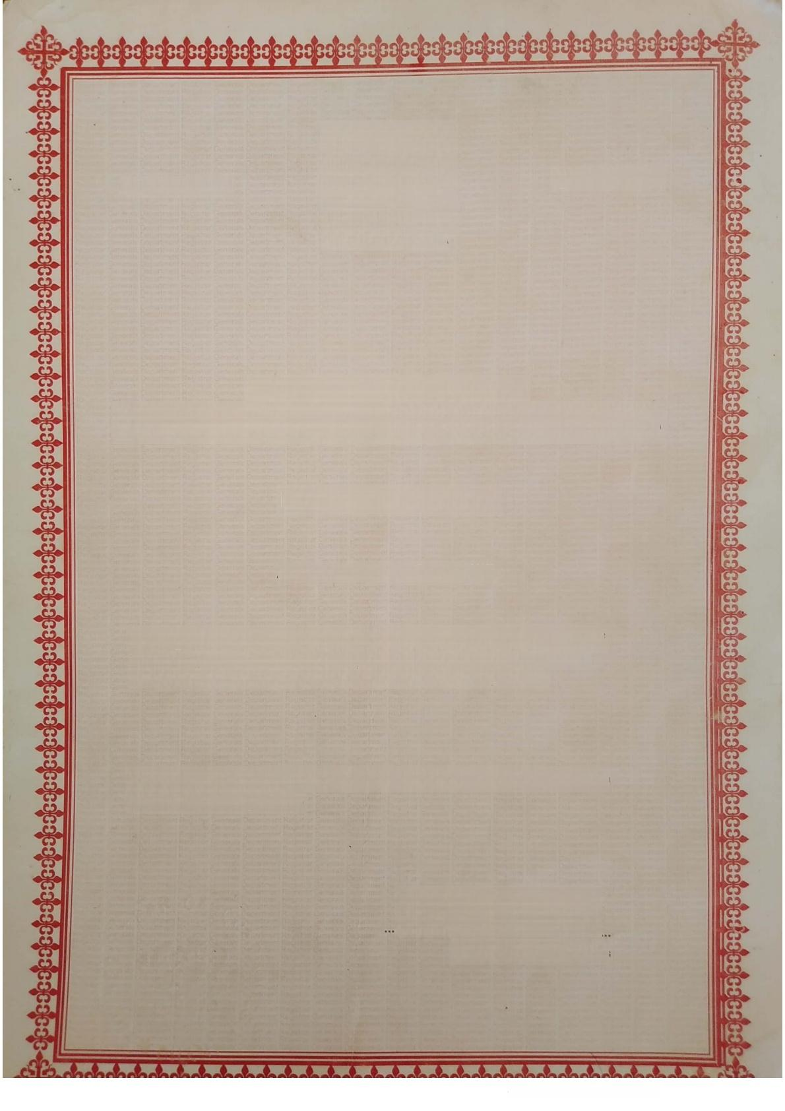**C0004652142**

**CS566112015**

REPUBLIC OF GHANA

**The Companies Act,1963,Act 179**

**Certificate To Commence Business**

**I hereby certify that**

**ASAWABA FARMS LIMITED**

having complied with the provisions of Sections 27 and 28 of

the Companies Act,1963,Act 179 is entitled to commence

business with effect from **19**th day of **February 2015**

Given under my hand and official seal at Tamale,this 19th

day of February 2015

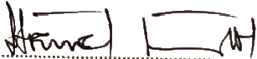

For:Registrar of Companies

**Scanned with CamScanner**