

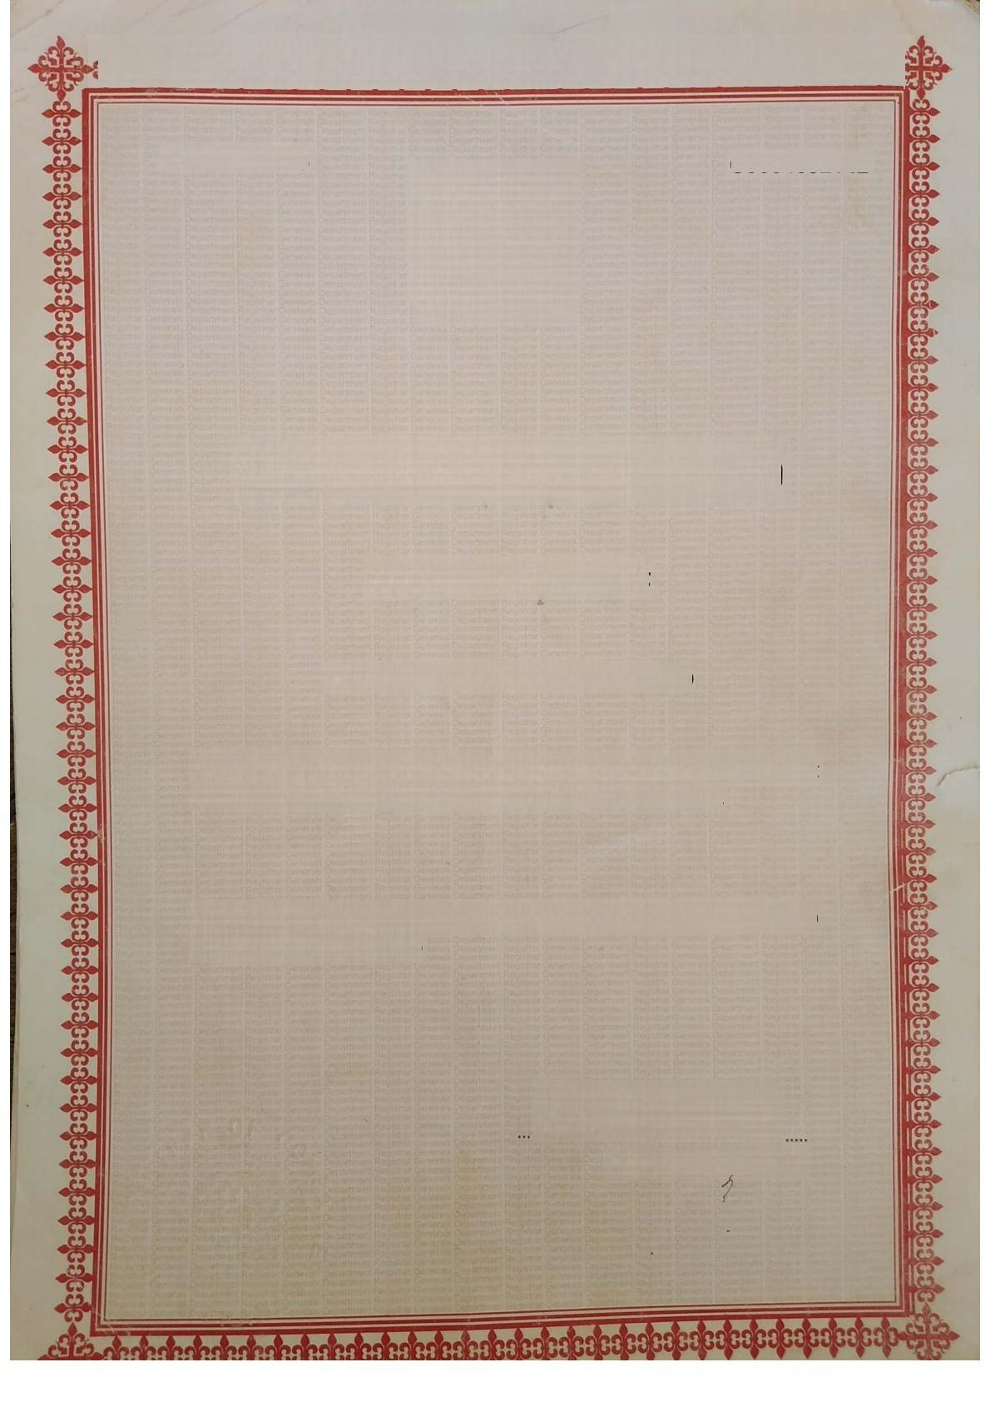**C0004652142**

**CS566112015**

REPUBLIC OF GHANA

**Certificate of Incorporation l hereby certify that**

**ASAWABA FARMS LIMITED**

is this day incorporated under the Companies Act,1963(Act 179)and that the liability of its members is limited.

Given under my hand and official seal at Tamale,this 17th day of February 2015



For:Registrar of Companies